Draft - Memo
Date: | Tuesday, November 18, 2014
Project: | I-4 SAMR Re-evaluation
To: | Beata Styś Pałasz, PE, FDOT District Five
From | Hari Salkapuram, PE, HDR; Suraj Pamulapati, PE, HDR
Subject: | Lake Mary Blvd Interchange Alternatives Evaluation

- Purpose

The Florida Department of Transportation (FDOT) has requested to evaluate interchange alternatives for the Lake Mary Blvd interchange in the north section presented in the Interstate 4 (I-4) Systems Access Modification Report (SAMR) Re-evaluation in support of “I-4 Beyond the Ultimate (BtU)” PD&E Reevaluation Study.

- Project Location

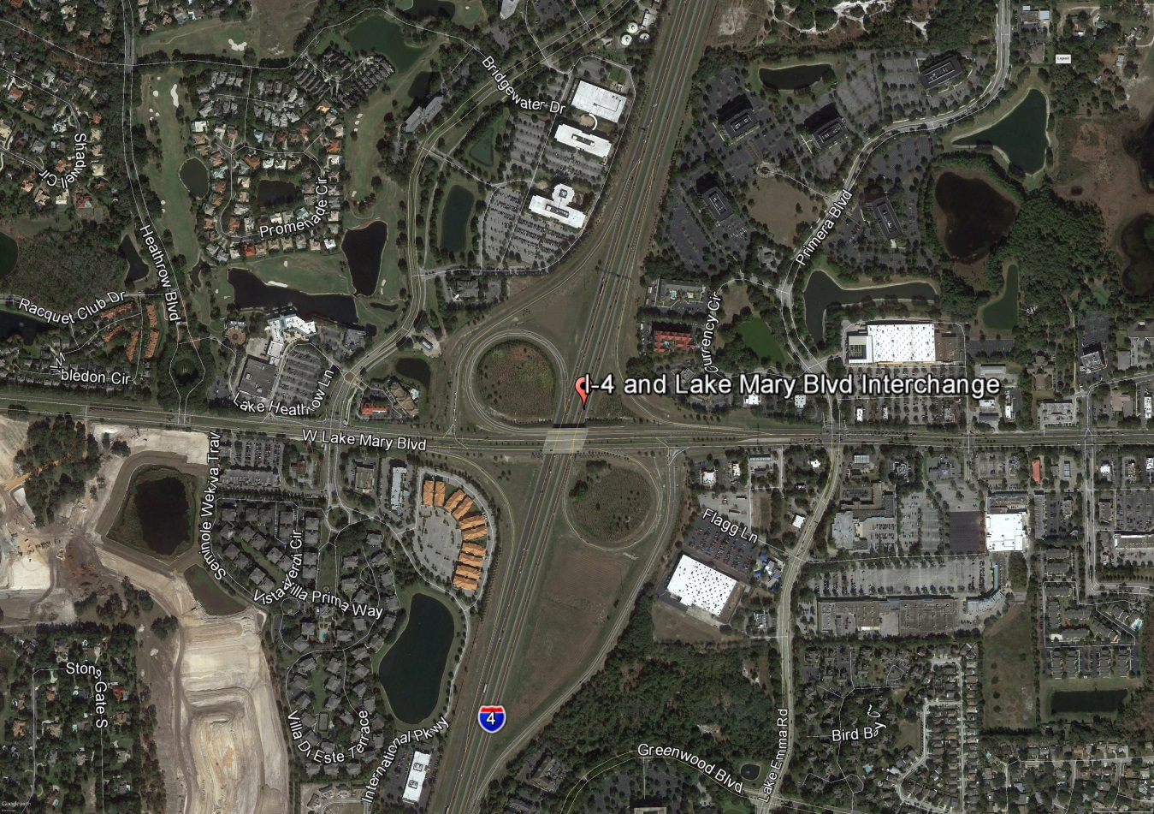
Figure 1: Lake Mary Boulevard Interchange Location

- Analysis Year

The analysis year for the alternative evaluation is the Design Year (2040).

- Traffic Forecasts

This traffic analysis for the analysis year 2040 was performed based on traffic forecasts developed as part of the I-4 SAMR Re-evaluation that is being prepared to support the I-4 BtU PD&E Reevaluation Study. The traffic forecasts for the analysis year 2040 are included in Attachment A.

- Interchange Alternatives

Three alternatives were considered for the Lake Mary Boulevard interchange evaluation. The list of alternatives is provided below and detailed geometry of the alternatives is provided in Attachment B.
- No-Build – Originally approved FHWA alternative
- Alternative 1 – Single Point Urban Interchange (SPUI)
- Alternative 2 – No-Build + Pedestrian Overpass across I-4+ Addt’l free NBR lane at I-4 WB Ramps intersection and exclusive 2nd EBR lane at Lake Emma Road intersection

- Operational Analysis

This section discusses peak-hour operational analysis using Synchro software. The results of the analysis and a comparison between the Alternatives are provided below.

  - Intersection Evaluation

A separate AM and PM peak-hour intersection analysis for study intersections was completed in Synchro for the study intersections on Lake Mary Boulevard.

Network-wide output provides insight into the comparison between the Alternatives. Based on the network performance comparisons, Alternative 2 provides improved operational performance for the 2040 AM and PM peak-hour periods (Table 1).

Table 1: Lake Mary Boulevard Intersections - Measures of Effectiveness (MOEs) Comparison

Synchro Intersection Delay and LOS Summary is shown in Table 2.

Table 2: Lake Mary Boulevard Intersections – Average Delay and LOS Comparison
  - Queue Analysis

The queuing results for the intersections of Lake Mary Boulevard with I-4 Ramps are summarized in Table 3 for the analysis year 2040. The results indicate that Alternative 2 results in better queue performance for both eastbound and westbound ramps.

Table 3: Queue Analysis Summary
- Conclusion

Based on the operational analyses of all the alternatives, Alternative 2 performs better than the other alternatives.

- Recommendation

Review of two alternatives in addition to No-Build was conducted for Lake Mary Boulevard interchange for the analysis year 2040. Based on the operational analysis, Alternative 2 provides better operational performance among the three alternatives, ultimately improving mobility throughout the Lake Mary Boulevard corridor. Based on the assessments and analyses of the alternatives, Alternative 2 is recommended. However, other factors such as costs, ROW, environmental considerations, and funding availability should be considered in the implementation.

