Draft-Memo
Date: | Thursday, October 02, 2014
Project: | I-4 SAMR Re-evaluation
To: | Beata Styś Pałasz, PE, FDOT District Five
From | Hari Salkapuram, PE, HDR; Suraj Pamulapati, PE, HDR
Subject: | SR 46 Interchange Alternatives Evaluation

- Purpose

The Florida Department of Transportation (FDOT) has requested to evaluate interchange alternatives for the SR 46 interchange in the north section presented in the Interstate 4 (I-4) Systems Access Modification Report (SAMR) Re-evaluation in support of “I-4 Beyond the Ultimate (BtU)” PD&E Reevaluation Study.

- Project Location

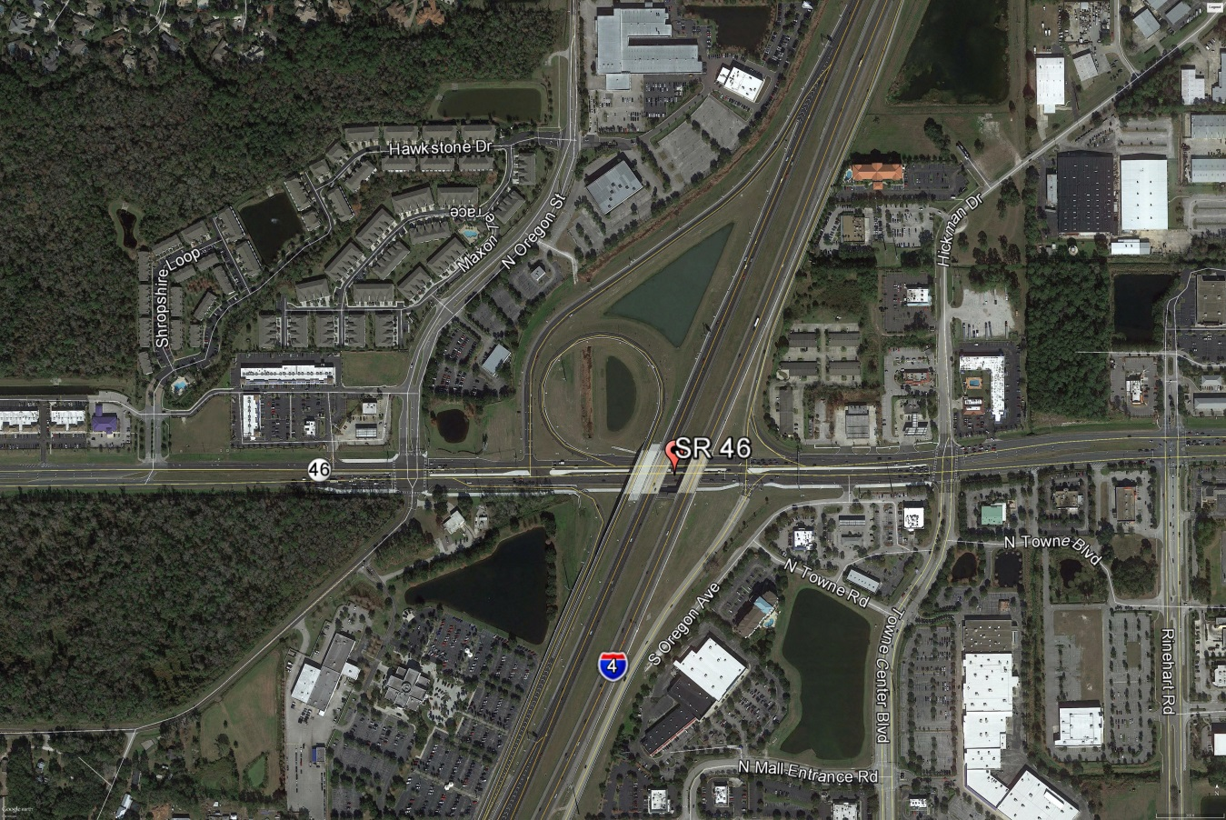
Figure 1: SR 46 Interchange Location

- Analysis Year

The analysis year for the alternative evaluation is the Design Year (2040).

- Traffic Forecasts

This traffic analysis for the analysis year 2040 was performed based on traffic forecasts developed as part of the I-4 SAMR Re-evaluation that is being prepared to support the I-4 BtU PD&E Reevaluation Study. The traffic forecasts for the analysis year 2040 are included in Attachment A.

- Interchange Alternatives

Three alternatives were considered for the SR 46 interchange evaluation. The list of alternatives is provided below and detailed geometry of the alternatives is provided in Attachment B.
- No-Build – Originally approved FHWA alternative
- Alternative 1 – No-Build + second eastbound left turn lane at eastbound ramps intersection
- Alternative 2 – Alt 1 + Slip Ramp from I-4 eastbound off ramp at SR 46 to N Towne Road/Towne Center Boulevard

- Operational Analysis

This section discusses peak-hour operational analysis using Synchro software. The results of the analysis and a comparison between the Alternatives are provided below.

  - Intersection Evaluation

A separate AM and PM peak-hour intersection analysis for study intersections was completed in Synchro for the study intersections on SR 46.

Network-wide output provides insight into the comparison between the Alternatives. Based on the network performance comparisons, Alternatives 1 and 2 provide improved operational performance for the 2040 AM and PM peak-hour periods while Alternative 2 provides marginally better performance than Alternative 1 (Table 1).

Table 1: Lake Mary Boulevard Intersections - Measures of Effectiveness (MOEs) Comparison

Synchro Intersection Delay and LOS Summary is shown in Table 2.

Table 2: Lake Mary Boulevard Intersections – Average Delay and LOS Comparison
  - Queue Analysis

The queuing results for the intersections of SR 46 with I-4 Ramps are summarized in Table 3 for the analysis year 2040. The results indicate that Alternative 2 results in better queue performance for both eastbound and westbound ramps.

Table 3: Queue Analysis Summary
- Conclusion

Based on the operational analyses of all the alternatives, Alternative 2 performs better than the other alternatives.

- Recommendation

Review of two alternatives in addition to No-Build was conducted for SR 46 interchange for the analysis year 2040. Based on the operational analysis, Alternative 2 provides better operational performance among the alternatives. Based on the assessments and analyses of the alternatives, Alternative 2 is recommended. However, other factors such as costs, ROW, environmental considerations, and funding availability should be considered in the implementation.

