Draft-Memo
Date: | Tuesday, November 18, 2014
Project: | I-4 SAMR Re-evaluation
To: | Beata Styś Pałasz, PE, FDOT District Five
From | Hari Salkapuram, PE, HDR; Smith Siromaskul, P.E., P. Eng.
Subject: | US 17/92 Interchange Alternatives Evaluation

- Purpose

The Florida Department of Transportation (FDOT) has requested to evaluate interchange alternatives for the US 17/92 interchange in the north section presented in the Interstate 4 (I-4) Systems Access Modification Report (SAMR) Re-evaluation in support of “I-4 Beyond the Ultimate (BtU)” PD&E Reevaluation Study.

- Project Location

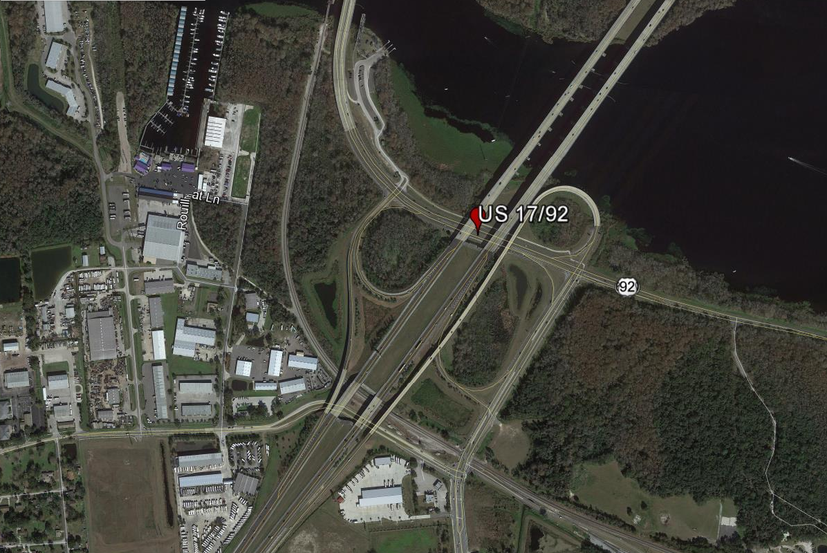
Figure 1: US 17/92 Interchange Location

- Analysis Year

The analysis year for the alternative evaluation is the Design Year (2040).

- Traffic Forecasts

This traffic analysis for the analysis year 2040 was performed based on traffic forecasts developed as part of the I-4 SAMR Re-evaluation that is being prepared to support the I-4 BtU PD&E Reevaluation Study. The traffic forecasts for the analysis year 2040 are included in Attachment A.

- Interchange Alternatives

In addition to No-Build and Original Build, Four other alternatives were considered for the US 17/92 interchange evaluation. The list of alternatives is provided below and detailed geometry of the alternatives is provided in Attachment B.
- No-Build
- Original Build – FHWA approved alternative.
- Alternative 1
- Alternative 2
- Alternative 3
- Alternative 4
VISSIM screen captures for the alternatives 1 through 4 are provided below.
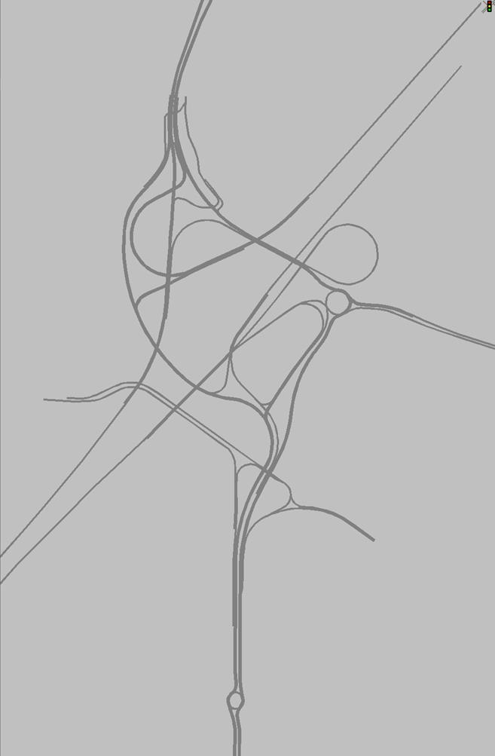
Figure 2: Alternative 1

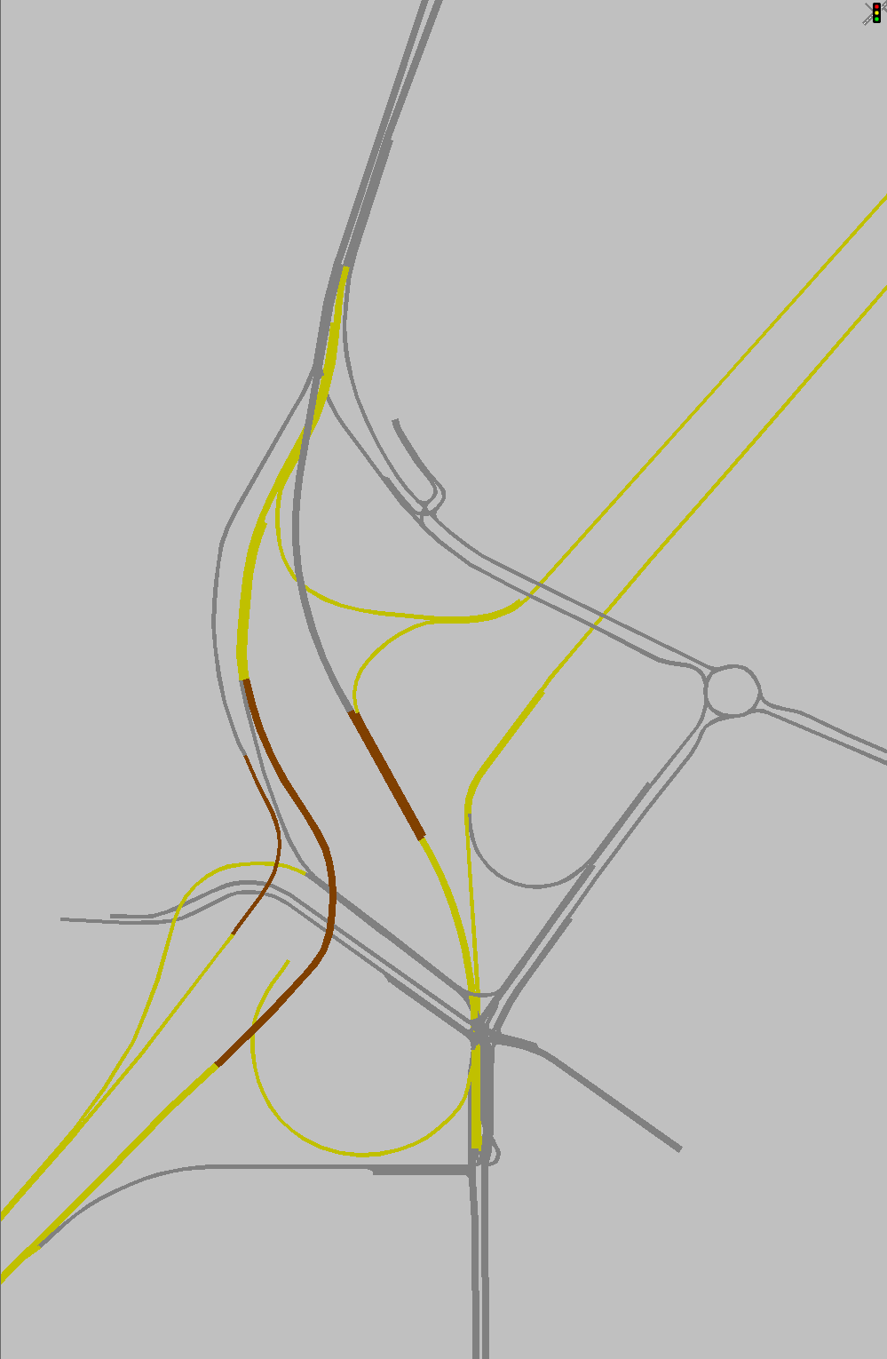
Figure 3: Alternative 2

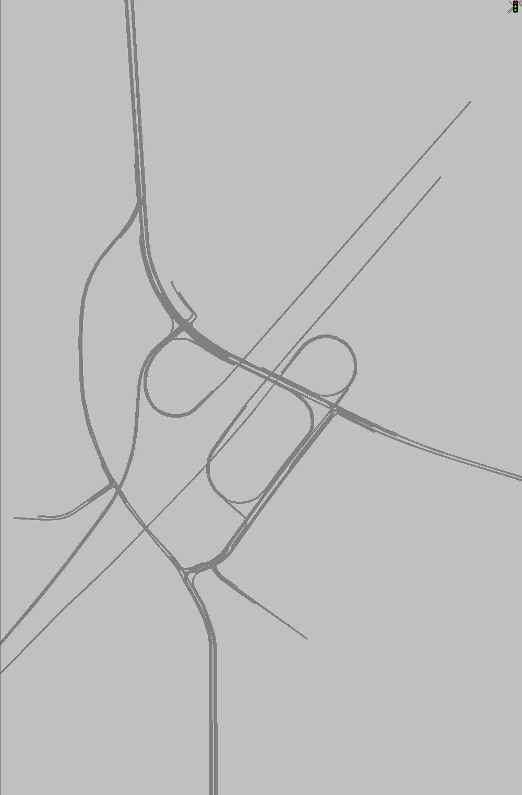
Figure 4: Alternative 3

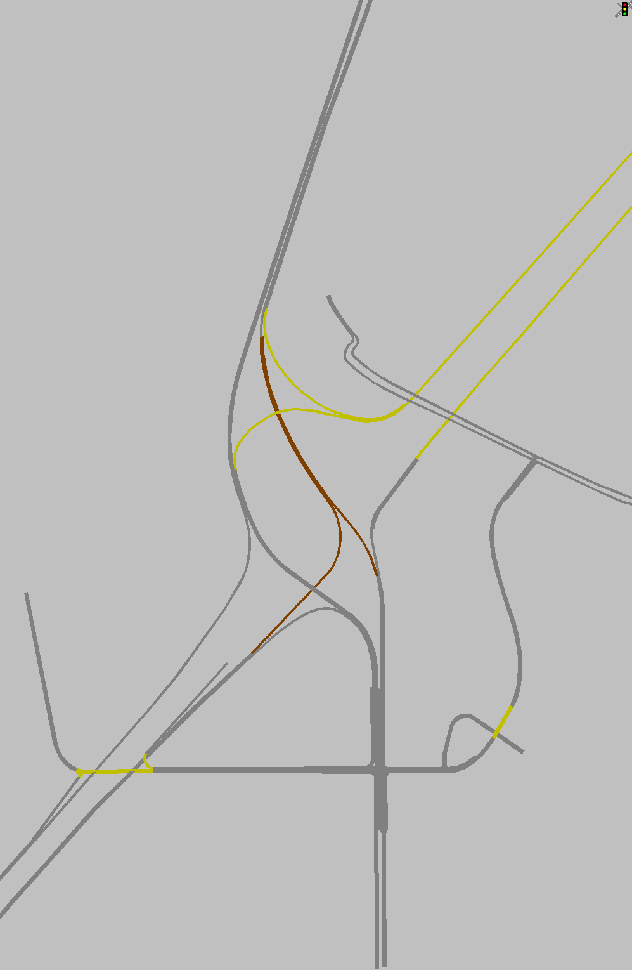
Figure 5: Alternative 4

- Operational Analysis

This section discusses peak-hour operational analysis using microsimulation software VISSIM version 5.4. The results of the analysis and a comparison between the Alternatives are provided below. It should be noted that the operational analysis is proof of concept and is not based on calibrated VISSIM models. All of the simulation output is based on the average data from five (5) simulation runs.

  - Node Evaluation

A separate AM and PM peak hour intersection analysis for study area intersections was not conducted due to the complex nature of the intersections. Given the unique geometry of the interchange improvements a direct comparison of intersection operations was not possible.

  - Network-Wide Output

Network-wide output provides insight into the comparison between the Alternatives. Based on the network performance comparisons, Alternative 2 provides the most improved operational performance for the 2040 AM and PM peak hour periods (see Table 1). When considering total delay within the network in addition to latent delay for vehicles that are unable to enter the network, the results indicate that with exception of Alternative 3, the alternatives 1, 2 and 4 perform equally better.

Table 1: Network Performance Comparison
  - Queue Analysis

A queuing analysis was performed at all ramp terminal intersections in order to determine maximum queue lengths (in feet) that would impact I-4. The queuing results for the intersections of US 17/92 and the I-4 ramps are summarized in Table 2 for the analysis year 2040. The results indicate that with exception of Alternative 3, the alternatives 1, 2 and 4 significantly reduce the queue lengths for both eastbound and westbound ramps for both the AM and PM conditions.

Table 2: Queue Analysis Summary

- Conclusion

Based on the operational analysis, the results indicate that with exception of Alternative 3, the alternatives 1, 2 and 4 perform equally better than No- Build.

- Recommendation

Review of four alternatives in addition to No-Build and Original Build was conducted for US 17/92 interchange for the analysis year 2040. Based on the operational analysis, the results indicate that with exception of Alternative 3, the alternatives 1, 2 and 4 perform equally better. Recommended alternative will be chosen based on other factors such as costs, ROW, environmental considerations, and funding availability should be considered in the implementation.

