Draft-Memo
Date: | Wednesday, October 15, 2014
Project: | I-4 SAMR Re-evaluation
To: | Beata Styś Pałasz, PE, FDOT District Five
From | Hari Salkapuram, PE, HDR; Suraj Pamulapati, PE, HDR
Subject: | Orange Camp Road Interchange Alternatives Evaluation

- Purpose

The Florida Department of Transportation (FDOT) has requested to evaluate interchange alternatives for the Orange Camp Road interchange in the north section presented in the Interstate 4 (I-4) Systems Access Modification Report (SAMR) Re-evaluation in support of “I-4 Beyond the Ultimate (BtU)” PD&E Reevaluation Study.

- Project Location

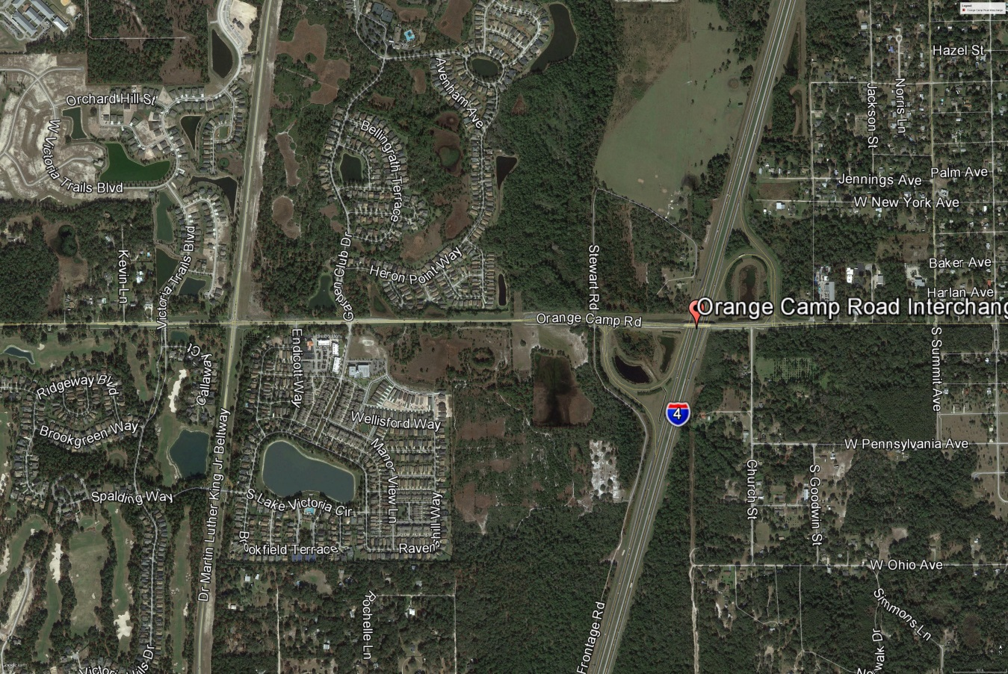
Figure 1: Orange Camp Road Interchange Location

- Analysis Year

The analysis year for the alternative evaluation is the Design Year (2040).

- Traffic Forecasts

This traffic analysis for the analysis year 2040 was performed based on traffic forecasts developed as part of the I-4 SAMR Re-evaluation that is being prepared to support the I-4 BtU PD&E Reevaluation Study. The traffic forecasts for the analysis year 2040 are included in Attachment A.

- Interchange Alternatives

Two alternatives were considered for the Orange Camp Road interchange evaluation. The list of alternatives is provided below and detailed geometry of the alternatives is provided in Attachment B.
- No-Build – Originally approved FHWA alternative
- Alternative 1 – Signals at both Eastbound and Westbound I-4 Ramps Intersections

- Operational Analysis

This section discusses peak-hour operational analysis using Synchro software. The results of the analysis and a comparison between the Alternatives are provided below.

  - Intersection Evaluation

A separate AM and PM peak-hour intersection analysis for study intersections was completed in Synchro for the study intersections on Orange Camp Road.

Network-wide output provides insight into the comparison between the Alternatives. Based on the network performance comparisons, Alternative 1 provides improved operational performance for the 2040 AM and PM peak-hour periods (Table 1).

Table 1: Orange Camp Road Intersections - Measures of Effectiveness (MOEs) Comparison

  - Queue Analysis

The queuing results for the intersections of Orange Camp Road with I-4 Ramps are summarized in Table 2 for the analysis year 2040. The results indicate that Alternative 1 results in better queue performance for both eastbound and westbound ramps for both the AM and PM peak hour conditions.

Table 2: Queue Analysis Summary
- Conclusion

Based on the operational analyses of the alternatives, Alternative 1 performs better than the No-Build Alternative.

- Recommendation

Review of only one alternative in addition to No-Build was conducted for Orange Camp Road interchange for the analysis year 2040. Based on the operational analysis, Alternative 1 provides better operational performance than No-Build Alternative. Based on the assessments and analyses of the alternatives, Alternative 1 is recommended.

