Draft-Memo
Date: | Thursday, October 02, 2014
Project: | I-4 SAMR Re-evaluation
To: | Beata Styś Pałasz, PE, FDOT District Five
From | Hari Salkapuram, PE, HDR; ; Suraj Pamulapati, PE, HDR
Subject: | Saxon Boulevard Interchange Alternatives Evaluation

- Purpose

The Florida Department of Transportation (FDOT) has requested to evaluate interchange alternatives for the Saxon Boulevard interchange in the north section presented in the Interstate 4 (I-4) Systems Access Modification Report (SAMR) Re-evaluation in support of “I-4 Beyond the Ultimate (BtU)” PD&E Reevaluation Study.

- Project Location

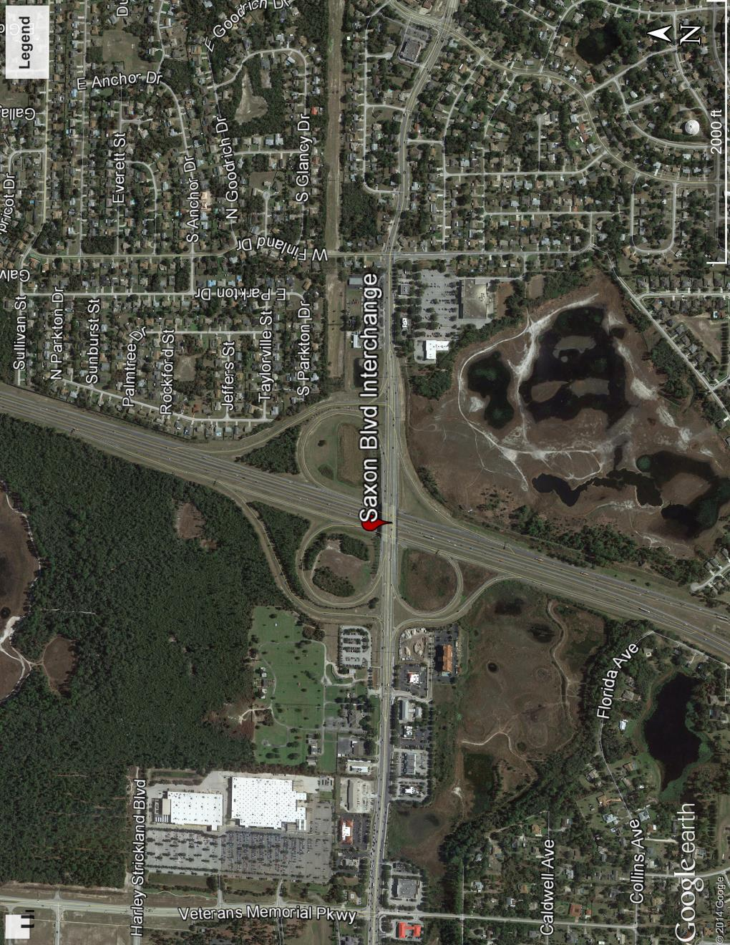
Figure 1: Saxon Blvd Interchange Location

- Analysis Year

The analysis year for the alternative evaluation is the Design Year (2040).

- Traffic Forecasts

This traffic analysis for the analysis year 2040 was performed based on traffic forecasts developed as part of the I-4 SAMR Re-evaluation that is being prepared to support the I-4 BtU PD&E Reevaluation Study. The traffic forecasts for the analysis year 2040 are included in Attachment A.

- Interchange Alternatives

Two alternatives were considered for the Saxon Boulevard interchange evaluation. The list of alternatives is provided below and detailed geometry of the alternatives is provided in Attachment B.
- No-Build
- Alternative 1– This alternative consists of following intersection improvements in additiona to No-Build geometry.
  - Continuous right turn lane in both eastbound and westbound directions between the east bound ramps terminal and Finland Drive intersection.
  - Saxon Blvd widening to three lanes from eastbound ramps terminal to Normandy Blvd intersection.
  - A second northbound left turn and an exclusive southbound left turn at Finland drive intersection.
  - Dual northbound left turns, dual eastbound left turns and a southbound channelized free flow right turn at Normandy Blvd intersection

- Operational Analysis

This section discusses peak-hour operational analysis using Synchro software. The results of the analysis and a comparison between the Alternatives are provided below.

  - Intersection Evaluation

A separate AM and PM peak-hour intersection analysis for study intersections was completed in Synchro for the study intersections on Saxon Blvd.

Network-wide output provides insight into the comparison between the Alternatives. Based on the network performance comparisons, Alternative 1 provides improved operational performance for the 2040 AM and PM peak-hour periods (Table 1).

Table 1: Saxon Boulevard Intersections - Measures of Effectiveness (MOEs) Comparison
Synchro Intersection Delay and LOS Summary is shown in Table 2.

Table 2: Saxon Boulevard Intersections – Average Delay and LOS Comparison
  - Queue Analysis

The queuing for both eastbound and westbound ramps was not conducted because the ramp movements are free flow.

- Conclusion

Based on the operational analyses of No-Build alternative and Alternative 1, Alternative 1 performs better than No-Build Alternative.

- Recommendation

Review of Alternative 1 in addition to No-Build was conducted for Saxon Blvd interchange for the analysis year 2040. Based on the operational analysis, Alternative 1 provides better operational performance than No-Build. Based on the assessments and analyses of the alternatives, Alternative 1 is recommended. However, other factors such as costs, ROW, environmental considerations, and funding availability should be considered in the implementation.

