March 27, 2020

Dear Property Owner or Other Interested Stakeholder:

Subject: Public Notification
I-4 Beyond the Ultimate Interim Design Projects
Osceola County
Financial Project Identification (FPID) Nos.: 444187-1, 444329-1, 443958-1

The Florida Department of Transportation (FDOT) and Osceola County are designing improvements to Interstate 4 (I-4) and County Road (C.R.) 532 near ChampionsGate in Osceola County. The purpose of these projects is to provide operational and safety improvements to the I-4 and C.R. 532 interchange, as well as on I-4 between C.R. 532 and State Road (S.R.) 429.
Among the proposed improvements is construction of a raised bi-directional median at the intersection of ChampionsGate Boulevard and Goodman Road. The median would restrict left turns from Goodman Road to ChampionsGate Boulevard. In accordance with Florida Statute 335.199 regarding notification of access changes, the department is sending notices to stakeholders affected by access changes at the ChampionsGate Boulevard and Goodman Road intersection.

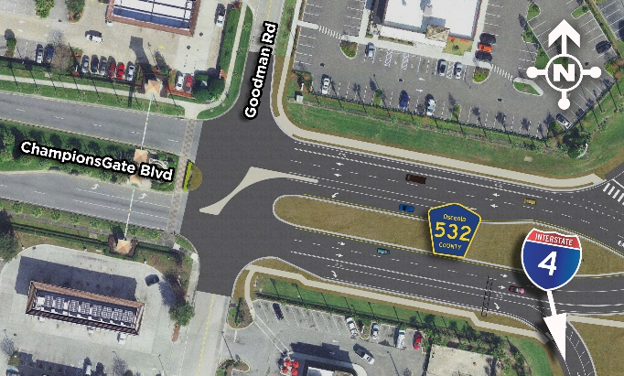
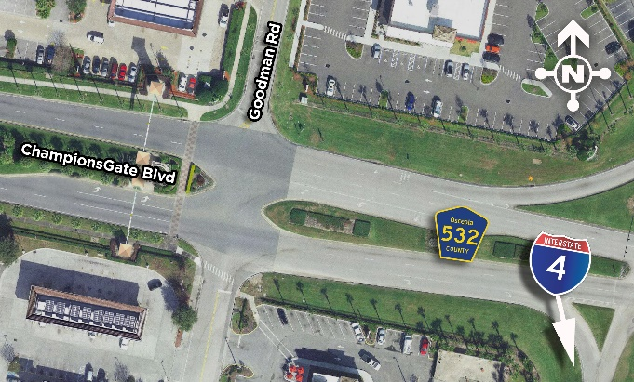
CURRENT CONDITIONS PROPOSED CONDITIONS

A public hearing will be held at a future date to present information and obtain public input regarding the proposed designs. In the meantime, we encourage you to learn more about this project as well as the additional projects explained below that are being done in conjunction with this work. We welcome your comments, please share them with us by contacting the individuals listed at the end of this letter or by going to the project website at www.I4Beyond.com/ChampionsGate. All comments will become part of these projects’ public record.
Information about the following projects is available on the website:
- I-4 and C.R. 532 Interchange Reconfiguration (FPID No. 444187-1): These design plans reconfigure the I-4 and C.R. 532 interchange to a diverging diamond interchange (DDI) to improve safety and operations in the area. This is a joint project between Osceola County and FDOT. The county is designing the project and FDOT will oversee its construction. A DDI removes turns across oncoming traffic to help increase traffic flow. The project will also add bike lanes and sidewalks along C.R. 532 for improved bicycle and pedestrian connectivity and safety. Construction is anticipated to begin in the spring of 2021.
- I-4 Auxiliary Lane Additions (FPID No. 444329-1): This FDOT project includes the addition of new eastbound and westbound I-4 auxiliary lanes, one in each direction, between the ramps of S.R. 429 and C.R. 532, as well as an auxiliary lane on northbound S.R. 429 between I-4 and Sinclair Road. The westbound I-4 exit ramp and the eastbound I-4 entrance ramp at the C.R. 532 interchange will also be widened to two lanes to increase traffic flow and capacity. The project includes milling and resurfacing S.R. 429 between I-4 and Sinclair Road. Construction is anticipated to begin in the fall of 2021.
- I-4 Milling and Resurfacing (FPID No. 443958-1): Plans for this FDOT project will mill and resurface eastbound and westbound I-4 from the Polk-Osceola County line to west of S.R. 417. Construction is anticipated to begin in the fall of 2021.
If you have any questions about the ChampionsGate diverging diamond interchange, please contact Conroy Jacobs, AICP, Osceola County Project Manager, at 407-742-0557, or by email at Conroy.Jacobs@osceola.org. Written comments regarding the proposed design of the I-4 and C.R. 532 interchange may be submitted by mail to Conroy Jacobs, Osceola County Project Manager, 1 Courthouse Square, Suite 3100 Kissimmee, FL 34741 or by email to Conroy.Jacobs@osceola.org, by Thursday, April 23, 2020.
If you have any questions about the auxiliary lane project, or the milling and resurfacing on
I-4, please contact Su Hao, P.E., FDOT Project Manager, at 386-943-5161, or by email at Su.Hao@dot.state.fl.us. Written comments regarding the I-4 improvements between C.R. 532 and S.R. 429 may be submitted by mail to Su Hao, FDOT Project Manager, 719 S. Woodland Blvd., MS 542, DeLand, FL 32720, or by email to Su.Hao@dot.state.fl.us, by Thursday, April 23, 2020.
Public participation is solicited without regard to race, color, national origin, age, sex, religion, disability or family status. Persons wishing to express their concerns relative to FDOT compliance with Title VI may do so by contacting Jennifer Smith, FDOT District Five Title VI Coordinator via email at Jennifer.Smith2@dot.state.fl.us.
Pursuant to the provisions of the Americans with Disabilities Act, any person requiring accommodations to participate in this workshop/meeting is asked to advise the agency at least seven (7) days before the workshop/meeting by contacting David Parks, Community Outreach Specialist at 844-858-4636, or by email at DavidParks@i4ultimate.com. If you are hearing or speech impaired, please contact the agency using the Florida Relay Service, 1-800-955-8771 (TDD) or 1-800-955-8770 (Voice).

Sincerely,
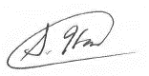
Su Hao, P.E.
Project Manager
Florida Department of Transportation

